**Sustainability Analytics - Manufacturing Sector**

GOKULNATH K & E24755

**Overview**

Sustainability analytics in the manufacturing sector involves tracking and analyzing environmental, social, and economic impacts. Data analysts use metrics such as energy consumption, waste generation, and carbon emissions to identify inefficiencies and optimize resource usage. They also support sustainable supply chain management by analyzing data on material sourcing and transportation. This helps manufacturers reduce their environmental footprint while improving operational efficiency and regulatory compliance.

**Objective**

1. Reduce Environmental Impact: Analyze energy, water, and material usage to minimize waste and emissions.
2. Optimize Resource Efficiency: Identify opportunities to improve production efficiency and reduce resource consumption.
3. Enhance Supply Chain Sustainability: Track and optimize sourcing, logistics, and transportation for lower environmental footprints.
4. Ensure Regulatory Compliance: Monitor and report sustainability metrics to meet environmental regulations and standards.
5. Support Sustainable Product Development: Use data to drive eco-friendly product designs and manufacturing processes.

**Assigned Task(s)**

* Sustainability Analytics - Manufacturing Sector

**Task Details**

* **Task 38 :** Sustainability analytics in the manufacturing sector helps data analysts track and optimize environmental metrics like energy use, waste, and emissions. It supports reducing environmental impact while improving operational efficiency and regulatory compliance.
* **Status:** Completed.
* **Details:**

1. Dataset Analyzed: A large synthetic dataset was Analyzed, including metrics like energy consumption, water usage, carbon emissions, and waste production.
2. Data Loading and Exploration: The dataset was loaded, and basic exploratory data analysis (EDA) was performed, including checking for missing values and summarizing key metrics.
3. Energy Consumption Analysis: Daily energy consumption patterns were analyzed and visualized to identify potential efficiency improvements.
4. Water Usage Analysis: Trends in daily water usage were tracked to highlight areas for conservation.
5. Carbon Emissions Analysis: Daily carbon emissions were monitored to evaluate emission reduction strategies.
6. Waste Production Analysis: Waste production trends were analyzed to support waste reduction initiatives.
7. Correlation Analysis: A correlation heatmap was generated to understand relationships between key sustainability metrics.

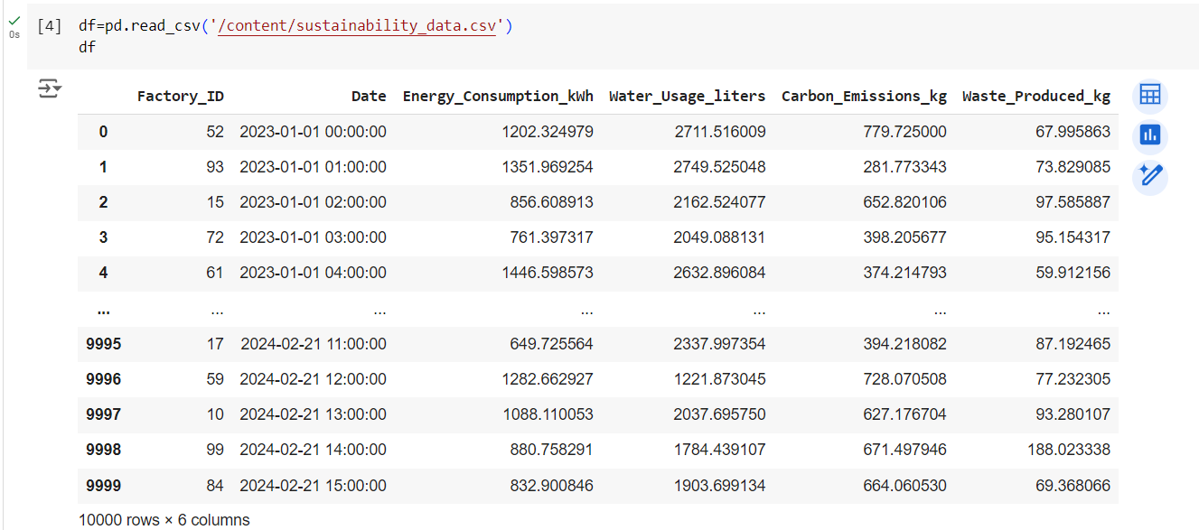

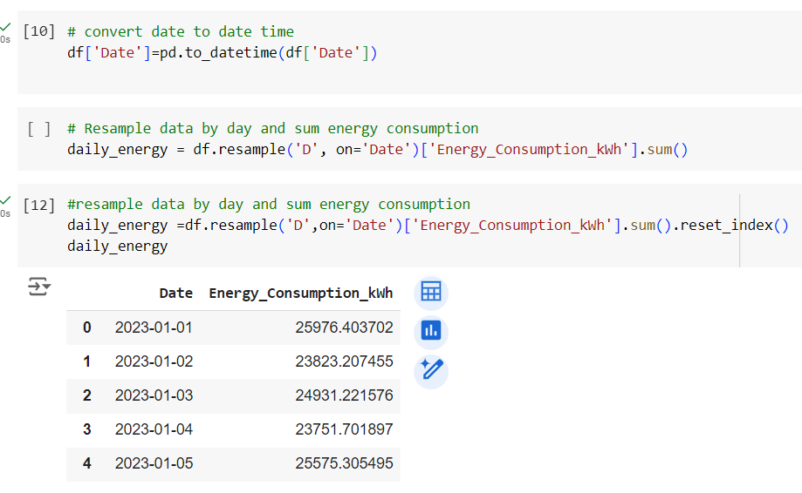

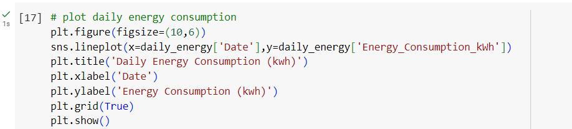

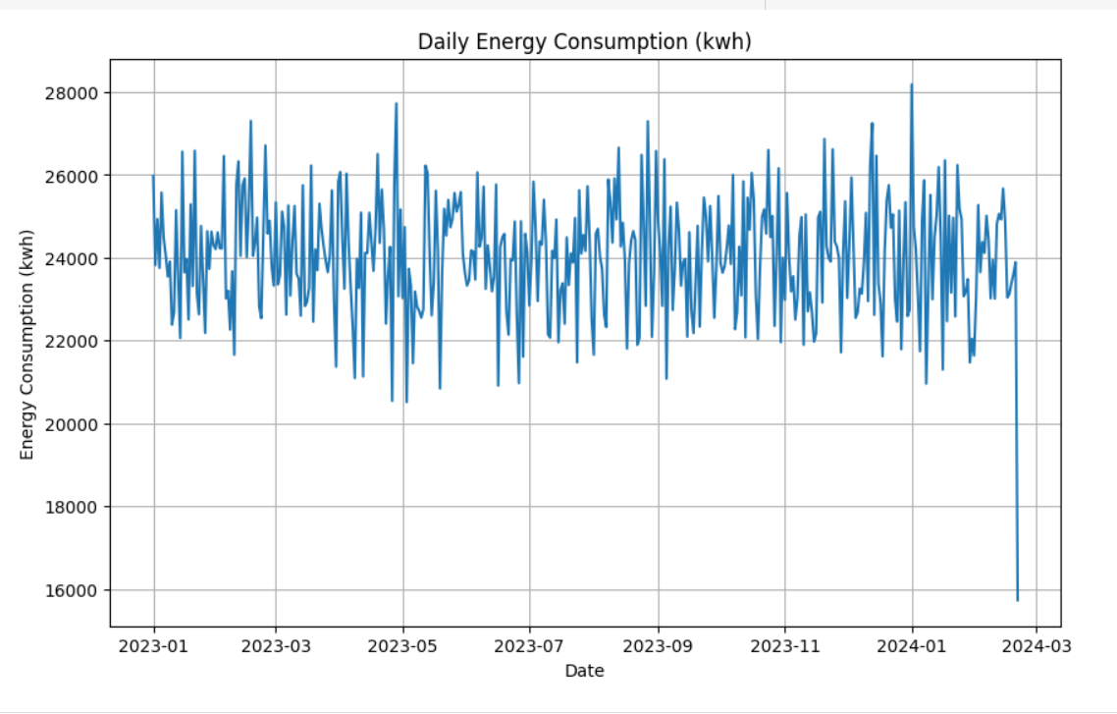

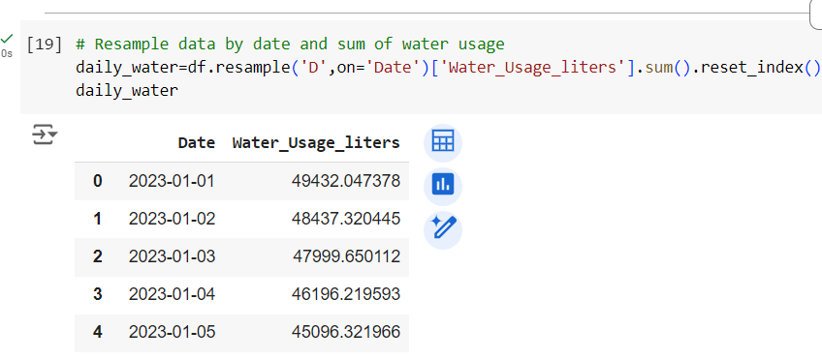

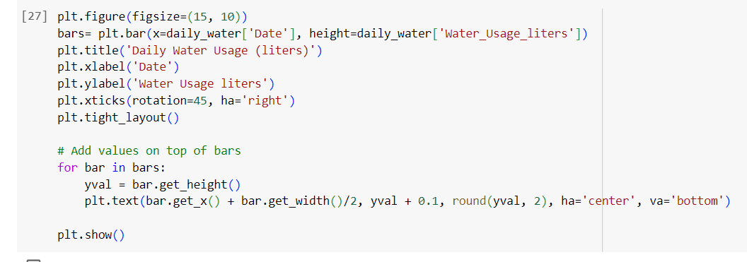

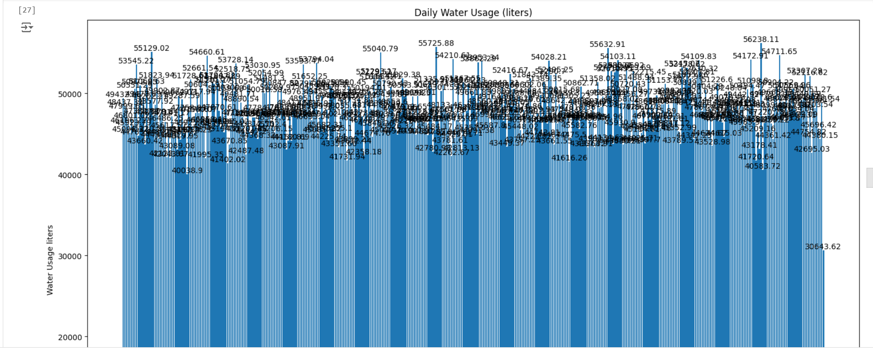

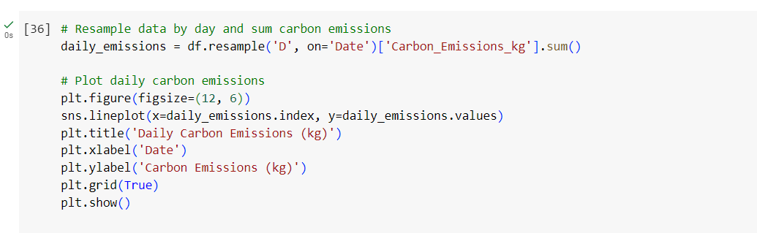

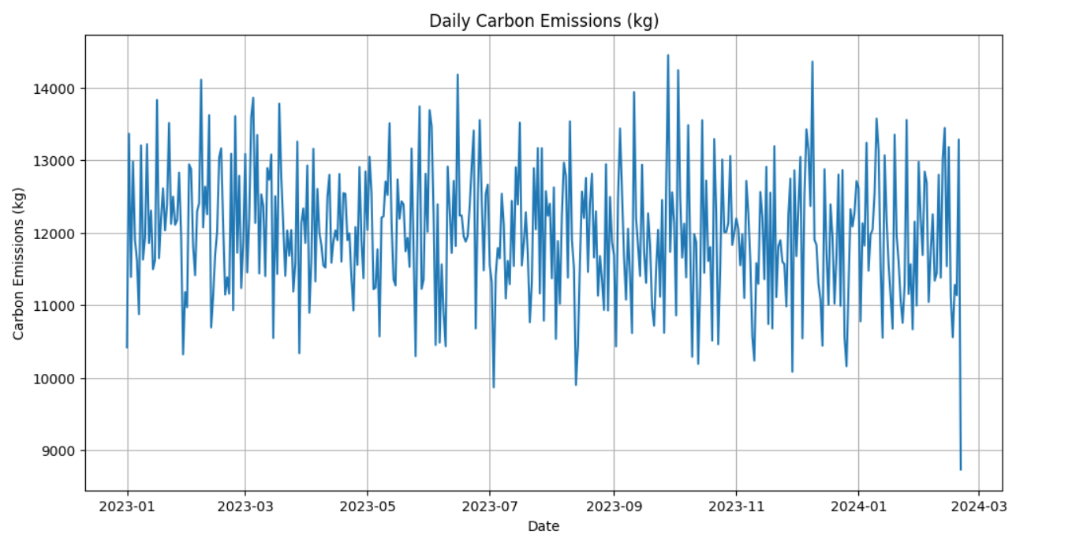

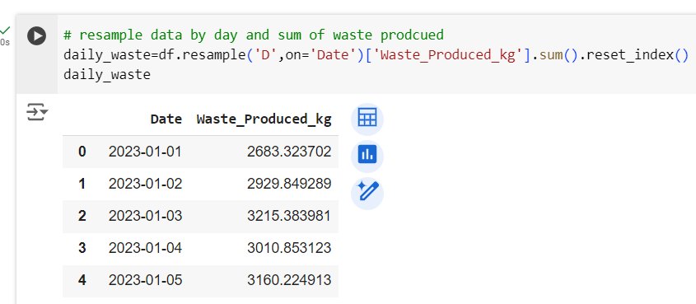

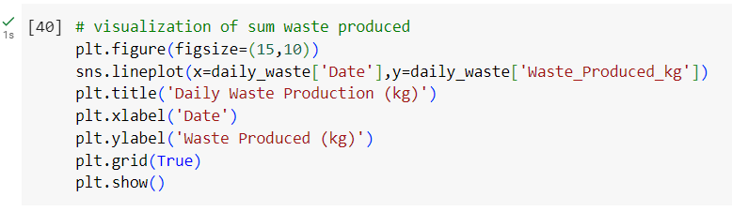

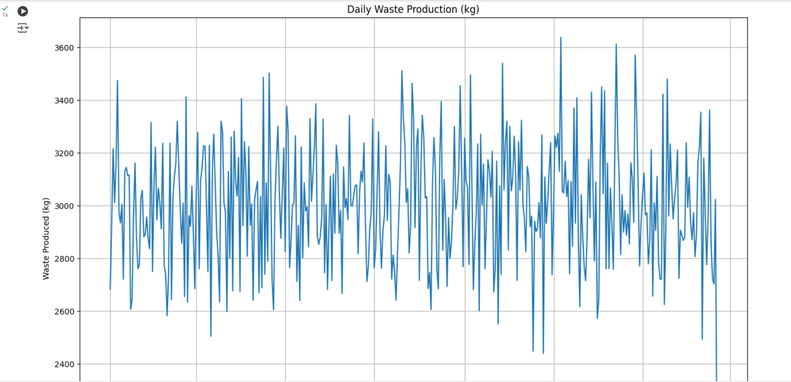

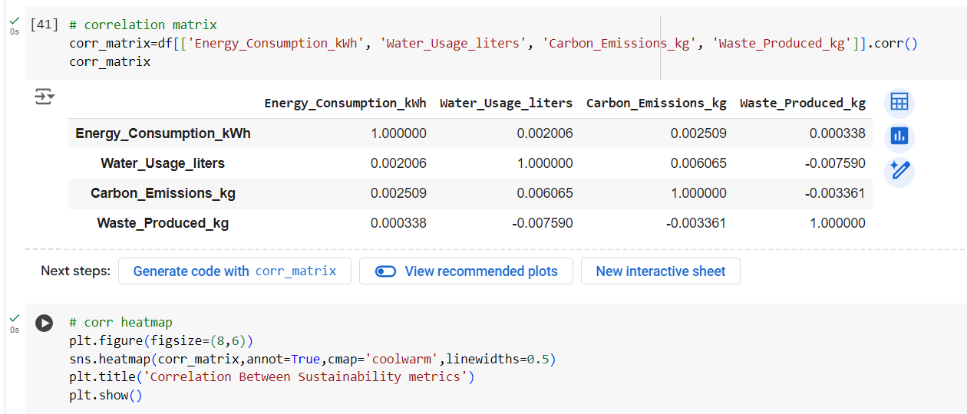

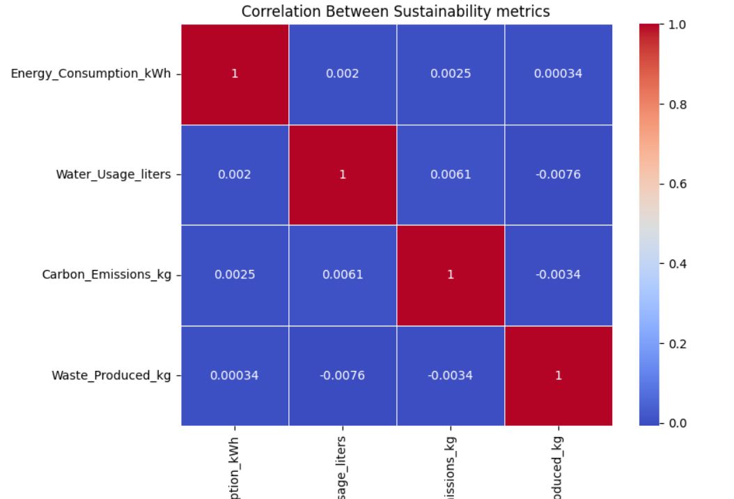

**Progress**

* **Accomplishments:**

1. Analyzed a dataset tracking energy, water, emissions, and waste metrics.
2. Performed exploratory data analysis (EDA) for insights and data quality checks.
3. Generated visualizations to highlight trends and identify efficiency opportunities.
4. Identified correlations between sustainability metrics for resource optimization.

* **Metrics:**

1. Measures the total energy used in production processes.
2. Tracks the volume of water consumed during manufacturing.
3. Quantifies the total carbon dioxide emissions generated.
4. Measures the amount of waste generated from manufacturing activities.

**Challenges and Solutions**

* **Challenges Faced:**

1. Keeping up with evolving sustainability regulations and standards.
2. Difficulty in accessing real-time metrics for timely decision-making.

* **Solutions Implemented:**

1. Regularly update processes and metrics to align with current regulations and sustainability goals.
2. Utilize Internet of Things (IoT) devices for continuous data collection to support real-time analytics and insights.

**Next Steps**

* **Upcoming Tasks:** Stay proactive by leveraging data-driven insights and collaborating with cross-functional teams to continuously improve sustainability practices in the manufacturing sector.
* **Goals:** Establish specific targets and track progress consistently to meet sustainability goals in the manufacturing sector.

**Conclusion**

* **Summary:** Sustainability analytics in the manufacturing sector is crucial for optimizing resource usage and reducing environmental impact. By leveraging data on energy consumption, water usage, carbon emissions, and waste production, organizations can make informed decisions to enhance efficiency and comply with regulations. Continuous monitoring and analysis pave the way for improved sustainability practices, ultimately contributing to a more sustainable future in manufacturing.
* **Acknowledgements:** Thank you all for your attention and engagement, I appreciate your interest in the Sustainability Analytics in the Manufacturing sector.